PostgreSQL Setup

[PostgreSQL: The world's most advanced open source database](https://www.postgresql.org/)

[PostgreSQL: Windows installers](https://www.postgresql.org/download/windows/)

[Community DL Page (enterprisedb.com)](https://www.enterprisedb.com/downloads/postgres-postgresql-downloads)

V15.1 64 bit

Type Super User Password: admin

After installation when you see this screen, Press Cancel to exit.

PostgreSQL Admin Tool

Select pgAdmin4

Use admin as a password

Connect to the server by entering admin as a password

Select PostgreSQL 15🡪Databases🡪postgres🡪Schema->Tables

Create a new table

Add Columns based on below format and press Save.

|  |
| --- |
| -- Table: public.customer  -- DROP TABLE IF EXISTS public."customer";  CREATE TABLE IF NOT EXISTS public."customer"  (  "id" integer NOT NULL DEFAULT nextval('"customer_id_seq"'::regclass),  name text COLLATE pg_catalog."default",  address text COLLATE pg_catalog."default",  phone text COLLATE pg_catalog."default",  CONSTRAINT "customer_pkey" PRIMARY KEY ("id")  )  TABLESPACE pg_default;  ALTER TABLE IF EXISTS public."customer"  OWNER to postgres; |

**To run queries in this table, sql shell tool**

Keep default values and enter admin as a password.

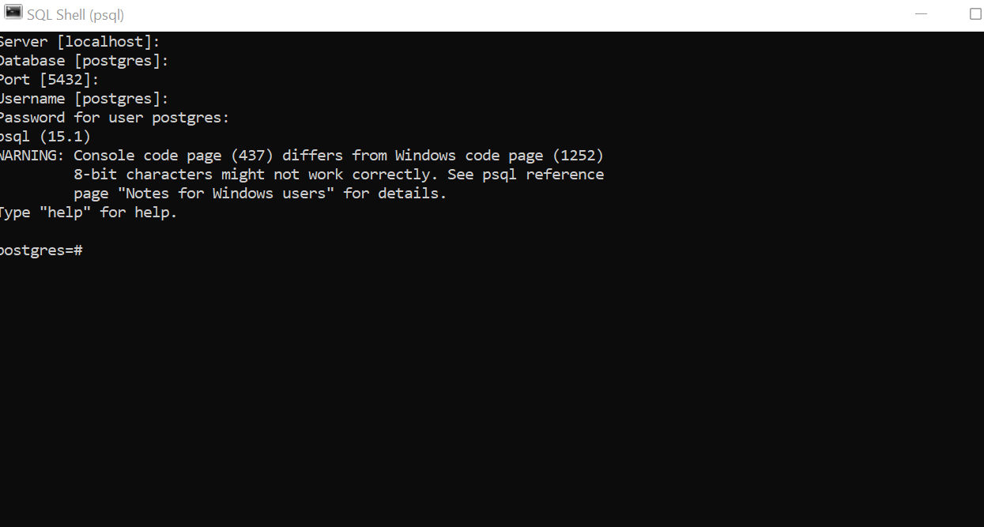

SELECT * FROM public."customer" order by "id" ASC;

insert into public."customer"(name,address,phone) values ('khan','Leiston Close','6778929');

Similar to this create Order and Complain tables

postgres=# insert into public."order"(customer_id,order_detail) values(1,'A new order');

postgres=# insert into public."order"(customer_id,order_detail) values(2,'2 new order');

postgres=# select * from public."order";

postgres=# insert into public."complain"(customer_id,complain) values(1,'first complain');

postgres=# insert into public."complain"(customer_id,complain) values(1,'second complain');

postgres=# select * from public."complain";

